COVER, REVISION HISTORY AND APPROVAL PAGE
Revision No. | Brief Description of Change | Effectivity Date
0 | Origination

 | Name | Signature
Originated/ Revised by: | Virtron K. Bumal-o  Project Manager | See DCN

Reviewed by: | Sherman A. Semanero  Project Manager | See DCN
 | Marjorie Laranang Olivete  Admin Director/ QMR | See DCN

Approved by: | Fernando C. Laranang  President/CEO | See DCN
Date Approved

Distribution List

President/CEO | Project Manager’s (2) | Document Controller
QMR/BOD’s | Admin (Common Copy)

- PURPOSE AND SCOPE

To develop procedures for concrete topping, ensuring proper coordination, quality control, inspection, documentation, and construction execution throughout the process, resulting in a durable, stable, and aesthetically pleasing floor surface that can be polished or act as a base for alternative flooring products.

- REFERENCE DOCUMENTS

FCLDC QAQC Manual
Plans and Specifications
Civil Engineer Mag

- DEFINITIONS

3.1 Definitions

Service agreement – Contract Between the General contractor stating the date the sub-contractor can begin work subject to the conditions stated on the agreement.

Plans and Specifications - a key part of the process of constructing a project. These documents are means of communicating between parties, and of ensuring that the appropriate designs, materials and construction techniques are used.

Bar Chart/S-Curve – a diagram showing the series of activities against timeliness until completion of the scope of works

QA/QC construction manual – a document that details the description of quality control systems that include staff roles and relationship, procedures and any other resources that relate to producing high quality work output.

Purchasing and Logistic Officer- the department responsible for the purchasing of materials and equipment needed for the project.

Topping concrete - is defined as a layer of high strength concrete placed on an old, worn-out concrete surface to provide a dense, abrasion-resistant surface, to increase structural depth and strength of the base concrete. Commonly use to cover conduits and insulations with min. thickness of 75mm and above

Concrete screed - a thin layer of cementitious material that is applied on top of a concrete slab or substrate. It serves as a leveling and smoothing agent, ensuring a flat and even surface. concrete screed eliminate any imperfections, such as gaps or unevenness, in the underlying concrete. Concrete screed can be at at a maximum of 3mm thk (Self leveling screed) to 50mm thk (throwel screed).
- GENERAL REQUIREMENTS

4.1 Equipment and Documents

    - Service agreement, plans and specifications
    - Certificates (NC2)
    - Laser guided plumb tools, 1.5m – 2.0m spirit level
    - Computers and office supplies

4.2 Materials

- Ordinary Portland cement is required.
- Sand must be free of any adhering coatings or other debris. 10mm coarse aggregate, as specified in the project.
- The water must be clean and fresh, suitable for residential use, and free of chemicals or additives that could impact the mix.
- The use of an approved bonding agent is required.

4.3 Safety and Environmental

    - Each worksite and employee function are thoroughly assessed in a manner that ensures safety for themselves, property owners and representatives, the general public, and the environment.

- PROCEDURE / INSTRUCTIONS

Procedure Outline

5.1 Service agreement and Orientation

5.2 Mobilization and installation of temporary facilities and Safety requirements

5.3 Project scheduling and Material take-off

5.4 Execution and Monitoring
5.4.1 Topping concrete
5.4.2 Concrete screed

5.5 Inspection and Billing Report

Procedure Details

Responsible Person | Activities | Interface Document/Person
 | 5.1 Service agreement and Orientation
Finance  Project Mananger | - Signing and Issuance of service agreement | Gencon and sub-con
QA/QC Engineer  Safety Officer  HR officer | - Conduct orientation on safety protocols, site rules and work hazards on the specific work.  - Orient the workers on the procedures and importance of quality control and assurance during the execution of the work | Contractor  NTP
 | - Mobilization and installation of temporary facilities and safety requirements
Technical Team | - Provide space for the temporary facilities of sub-contractors including designated C.R and washing area. | Sub-contractor
 | 5.3 Project Scheduling and Material take-off
Technical Team | - Provide specific schedule for the subcontractor’s guide. | Bar Chart/S-Curve
 | 5.4 Execution and Monitoring  - Topping concrete  - Site Engineer to issue approved plans and coordinate with the foreman to layout the area to be laid with concrete topping.  - Layout  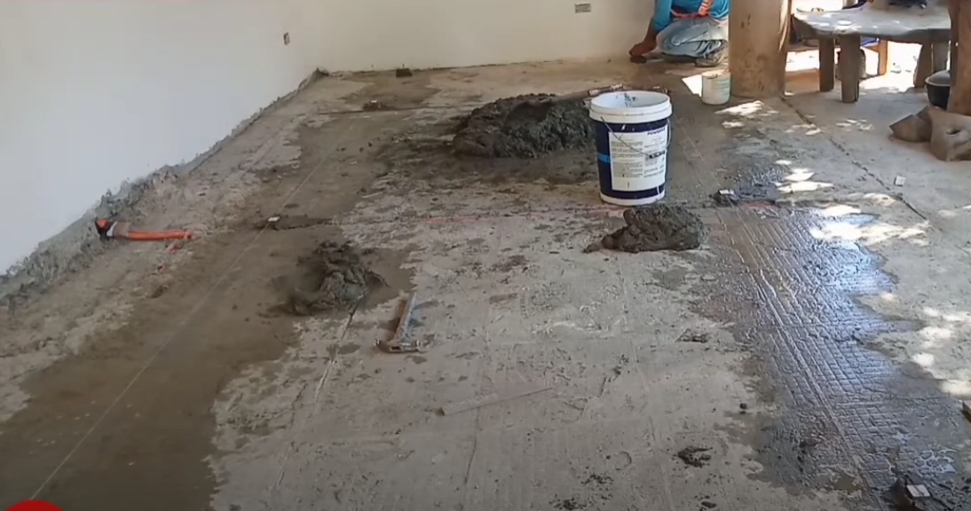Layout of concrete topping can be done using fixed dot leveled by straight edges and laser guided level,  Layout can also be done using straight edge guide parallel to each other and placed atleast 2m to 2.5m in between, leveled and fixed on floor to act as pouring guide. Fresh concrete is leveled thru straight edges passing perpendicular to the fixed guide. this sectional method of concrete topping is recommended on wide area such as parkings or warehouses.  - Preparation of Base Concrete  This is the important step in the laying of topping concrete, as this ensures the proper bonding and adhesion of old and new concrete. The concrete surface on which the topping slab is to be laid must be uniform, clean and free from dust particles or other contamination. Prior if any topping concrete is laid, it must be completely removed. If the base concrete is finished smoothly then the surface must be made course by the help of mechanical scabbing or scarification machine, so that the coarse aggregate of the base slab is exposed. The loose debris, dirt and dust must be removed using a vacuum cleaner. The timing of preparing the base concrete is of very important. The base preparation must be done a day before to the placing of topping slab, in order to prevent any contamination or accumulation of dirt.  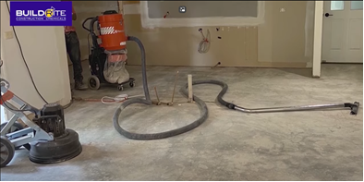  Vacuum of dust and removal of scaled concrete  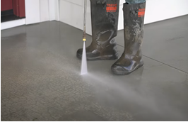  For dusty flooring use Pressure washer to remove scaling and fraking concrete  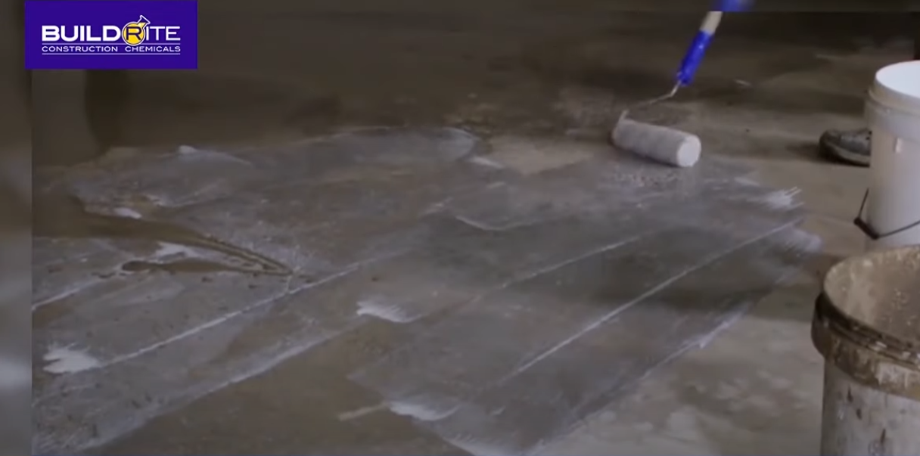  Application of bonding agent for old and fresh concrete  - Placing of Concrete Topping  - Before placing the topping concrete, site engineer must inspect and approved to proceed using concrete topping checklist form. use chemical bonding agent to ensure bonding of old and fresh concrete (for light traffic use Cement grip by Buildrite or equivalent, for heavy traffic use hardcrete fix bonding agent or equivalent)  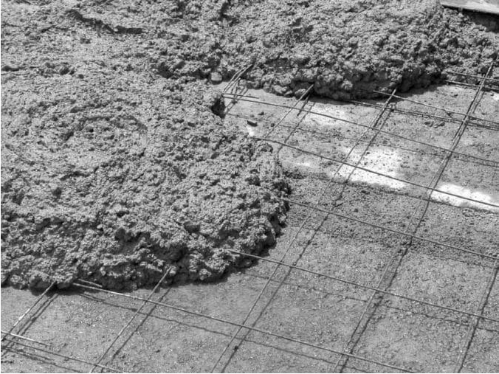  Installed mesh on concrete topping 75mm thk above    Portable vibrator  - Commonly placed concrete topping is in the range of 50-75 mm. for 75mm thk and above topping, 3mm x 4”x4” steel mesh reinforcement is provided with 1:3:3 cement-sand-gravel ratio. For 50mm below thickness, use 1:3:3 cement – sand, 3/8 gravel ratio, maximum slump is 75mm, vibrator must be used to avoid bubbling between the old and new concrete  - Surface finish  Once you’ve formed and poured the concrete, start the finishing process.  - Spread the concrete  - Use a square shovel or a come-along tool to push and pull the wet concrete into place.  - Screed the concrete  - During this step remove excess concrete and bring the surface of the concrete to proper grade. Use a straight board or special tool called a screed.  - Float the surface  - Use a darby or bull float to level ridges, fill voids and slightly embed the aggregate. Then allow the bleed water to disappear.  - Edge the slab  - Once all the bleed water is gone, create neat, rounded edges along the perimeter of the slab using an edger.  - Groove in joints  - Prevent unwanted cracks by jointing the slab with a grooving tool.  - Trowel the surface  - For a smooth, hard, dense surface, use a steel trowel or fresno for this step. Skip troweling if you plan to broom finish your concrete or add a decorative finish  - Concrete Screed  5.4.2.1 Work Tools and Equipment  - Hand Tools  - Wheelbarrow  - Portable Concrete Mixer  - Concrete pump  - Vibrator  - Air Compressor  - Trowel  - Aluminum Straight Edge  - Fork Shovel  - Survey Equipment  - Instruments for measuring (for cement sand, aggregate, and water)  During the mobilization stage, the above-mentioned equipment will be assigned according to the needs of each job.  5.4.2.2 Preparation  - Any loose or unsuitable material, such as mortar, wood, paint, curing compound, oil, and grease, should be removed from the surface slab.  - Ensure that all survey-related work is completed according to the most recent approved drawing. If the surface is smooth, concrete hacking with a chisel or hammering drill is advised, and the dust and loose material should be cleaned with a brush and high-pressure water jet to thoroughly erase the traces of the hacking.  - Ensure that waterproofing work is executed in accordance with the most recent approved drawing, project specification, and approved manufacture product datasheet.  - Prior to proceeding with the screed, coordinate and discuss with other disciplines (mechanical/electrical/piping, etc.) to ensure that all discipline operations have been finished and inspected. As per the most recent approved drawing, reinforcement may be required.  5.4.2.3 Mixing  The grade C16/20 screed will be utilized, and the properties of the material are as follows,  - The compressive strength of the mix design must be verified using a third-party test.  - On-site mix Screed (The following mix ratio should be used for the site mix.) 20 MPa compressive strength W/C (water to cement) ratio = 0.56 (cement – sand, 3/8 agregates) mixing ratio = 1:3  - Screeding / Pouring Screed  - Ensure that all measuring equipment and a mechanical mixer are available to manage the mixing ratio and that a supervisor supervises the mixing operation according to the permitted mixing ratio.  - The screed should be poured straight from the mixer using its lever and tilting capabilities in large or open areas such as lobbies, retail areas, and parking lots. Using hand fork shovels and pavers, distribute the screed and push it towards the corners.  - Install all embedded items prior to screeding operation.  - Damp the surface with water prior to starting to place of mortar screed. However, free water shall be removed from the top of the surfaces.  - After pouring and spreading the screed, it should be tapped with a flat trowel and an aluminum straight edge to ensure that it is level. Compact power trowel (helicopter trowel) shall be employed to tackle time measures in big and open regions.  - To establish extra bonding between concrete slabs and screed and to prevent hollow sounds or cracks, a bonding agent should be put to the direct concrete surface.  - The bonding agent must be applied according to the technical data sheet for the permitted material.  For formulated Screed product  Thickness: 3mm-50mm  Using Buildrite product  - Level up buildrite  - Self leveling formulated screed: 3mm min.  - Hardcrete 310 buildrite  - Trowel applied formulated screed: 10mm min.  Use narrow strips of screed materials, placed and compacted to the finished level to obtain the level of the screed.  5.4.2.5 Curing  Wind, draughts, and direct sunlight should all be avoided. Right after laying down. Cover the finished screed with burlap and polythene sheet for at least 7 days to cure.  5.4.2.6 Handover and Cleaning  The area will be completely cleaned once all of the events have been done. A “Request for Inspection” will be raised for acceptance once the cleaning is completed and accepted.  5.4.2.7 Maintenance of Screed Surfaces  The Safety Officer is responsible for ensuring that all areas of safety and house keeping are maintained. All demolished/removed materials must be deposited in a single designated area for pick-up and removal from the site.  Thin bed method using formulated screed  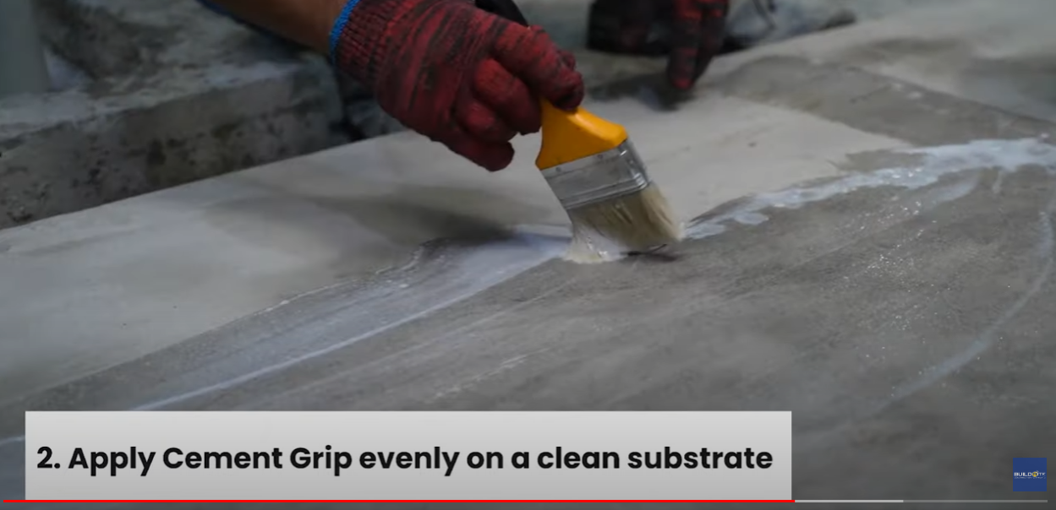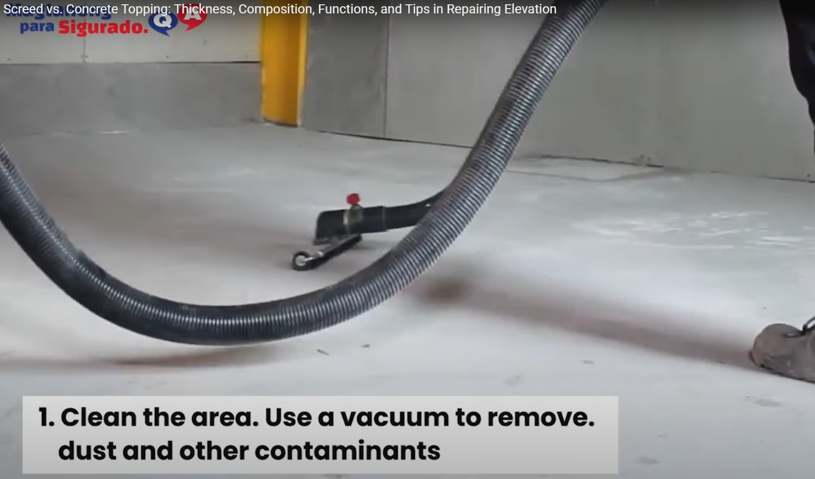  For light traffic use cement grip bonding agent by Buildrite or equivalent  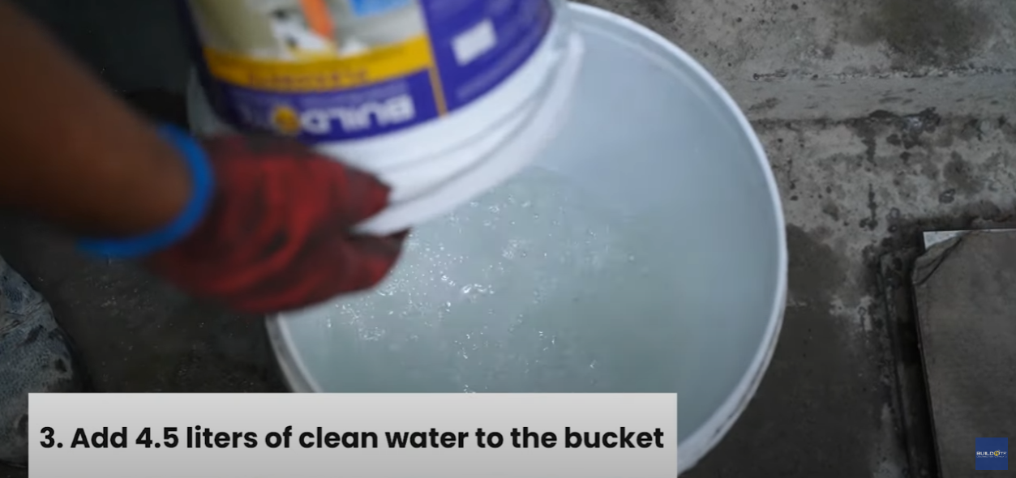  Verify method statement of the product  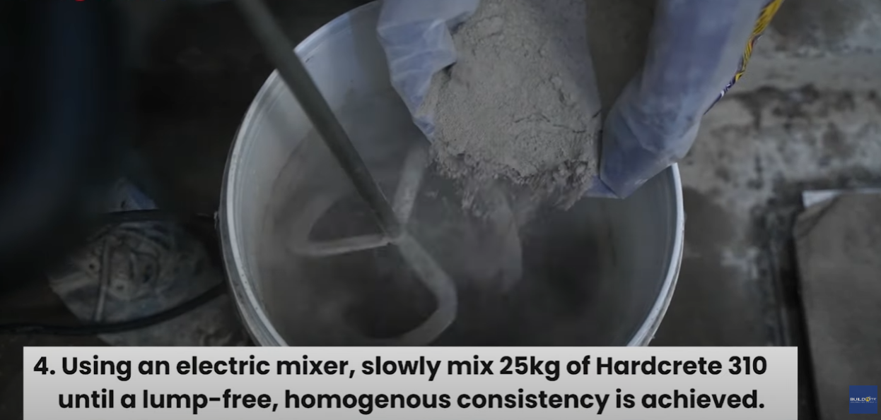  Products:  Hardcrete 303 – 3000 psi, 3mm min. thick  Hardcrete 410 – 4000 psi, 10mm min. thick  Hardcrete 520 – 5000 psi, 20mm min. thick  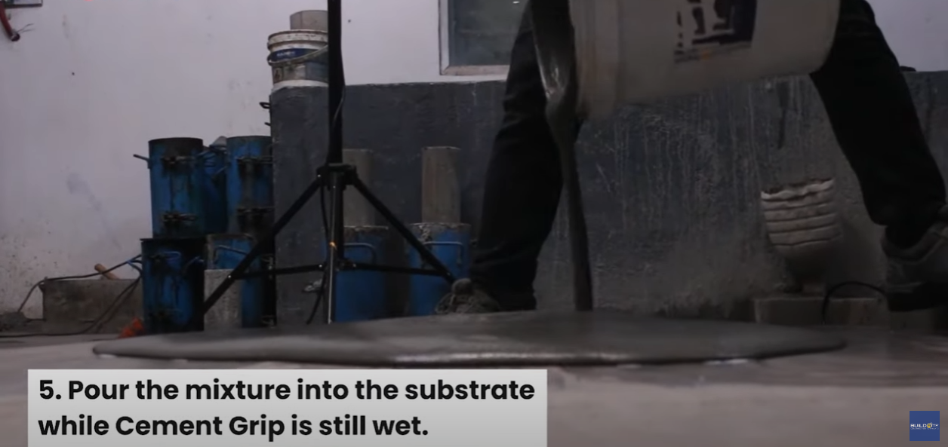  See method statement/Application of the product  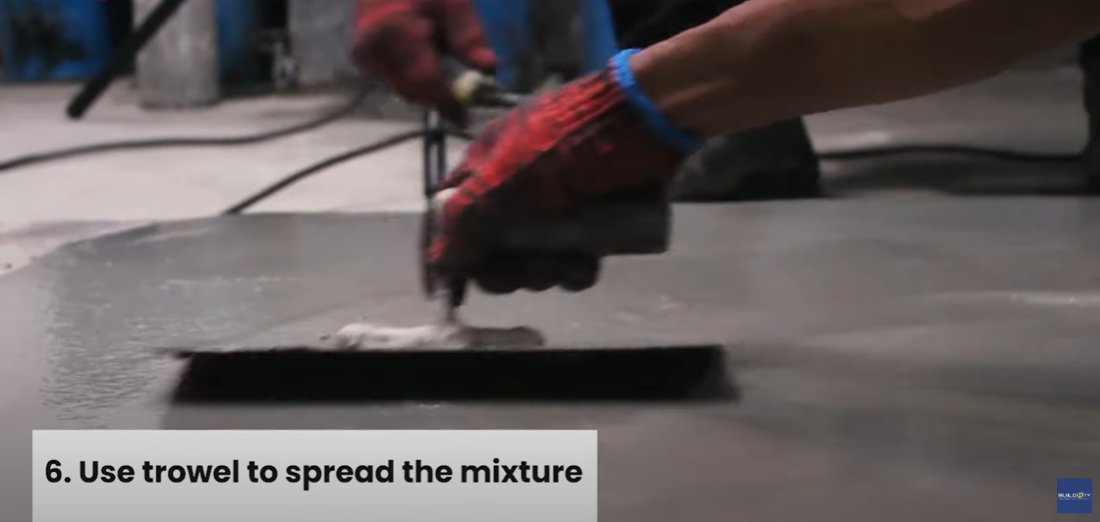  Use trowel to spread mixture  Use notch spreader and spike roller for self leveling product  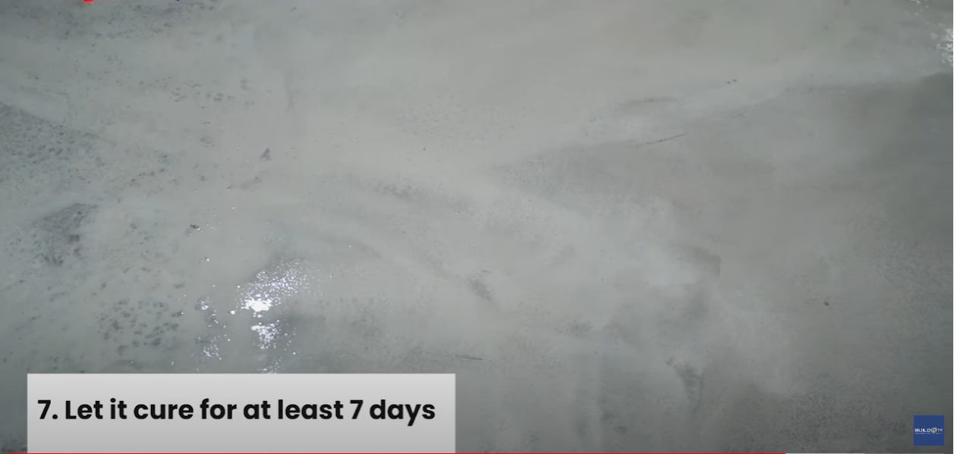  Reference: Best Concrete Topping for Large Areas + Floor Leveling Tips (youtube.com) | Concrete testing certificate pass 20 Mpa compressive strength  Concrete testing certificate pass 20 Mpa compressive strength

7.0 APPENDICES

Service Agreement

PM-OPN-02-14Masonry Checklist form

